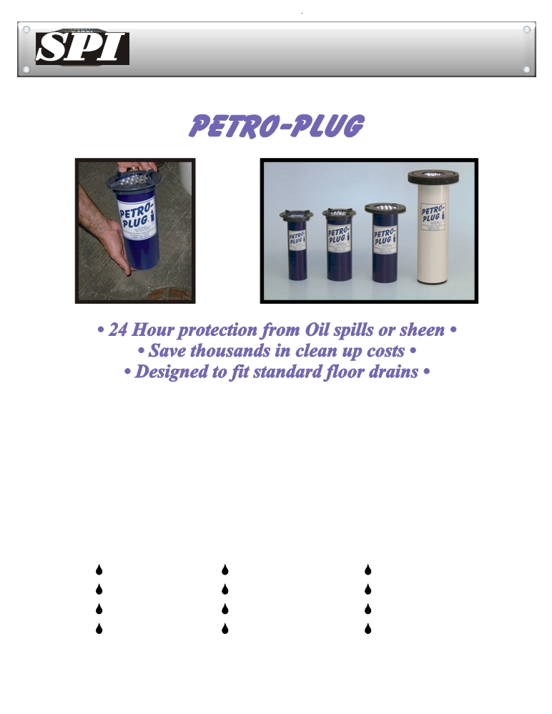

The First Attack Against Hydrocarbon Spills!
®

The

®
Petro-plug is designed to fit into standard 75 and 100mm floor drains allowing water to drain

®

while filtering out oil sheen. The patented Petro-plug , seals on contact with hydrocarbons,

shutting off any flow into sewer lines, sump pits, oil/water separators, catch basins, etc..

Petro-plugs are constructed from rigid PVC for strength and durability. The

Petro-plug has a

unique Twist-Lock top which provides a water tight seal allowing it to be installed or removed

quickly. To install simply remove the drain grate and glue the
®
®
Petro-plug mounting ring to the

outer diameter of the drain pipe. Then insert the

®
Petro-plug into the pipe and lock in place with

Petro-Plug
protects drains from:

Gasoline Transformer Oil Jet A Fuel

Diesel Motor Oil Cable Oil

# 4 Oil Hydraulic Oil Kerosene

Crude Oils Lubricating Oils PCB's … Etc .

Water Drains Oils Contained ™



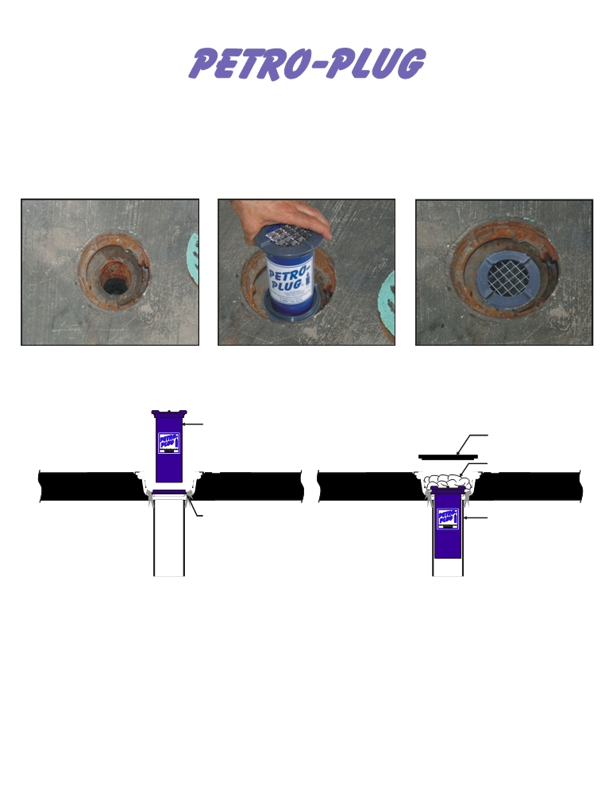

®

Our products are easy to install!

Prepare the drain by cleaning off any rust, dirt or grease.
The mounting ring is adhered with construction adhesive to the outer diameter of the drain pipe.

®
The Twist-Lock top allows the PETRO-PLUG
easily installed with just a quarter turn.

®
to be The PETRO-PLUG is now istalled protecting
the drain.



→



® US PATENTS 6485639•6503390•6841077 Other Patents Pending 






→



Petro-Plug® flow rates:
4” Diameter 4 litres per minute
3” Diameter 2 lites per minute
® US PATENTS 6485639•6503390•6841077 Other Patents Pending 


Oil Barriers Australasia
P.O.Box 47, Matangi, New Zealand .
peter@oilbarriers.co.nz / 0064 274 858763
www.oilbarriers.co.nz
US Patents 6485639, 6503390, 6841077 other US and foreign patents pending
SPI Services, LLC
Copyright © 2006

