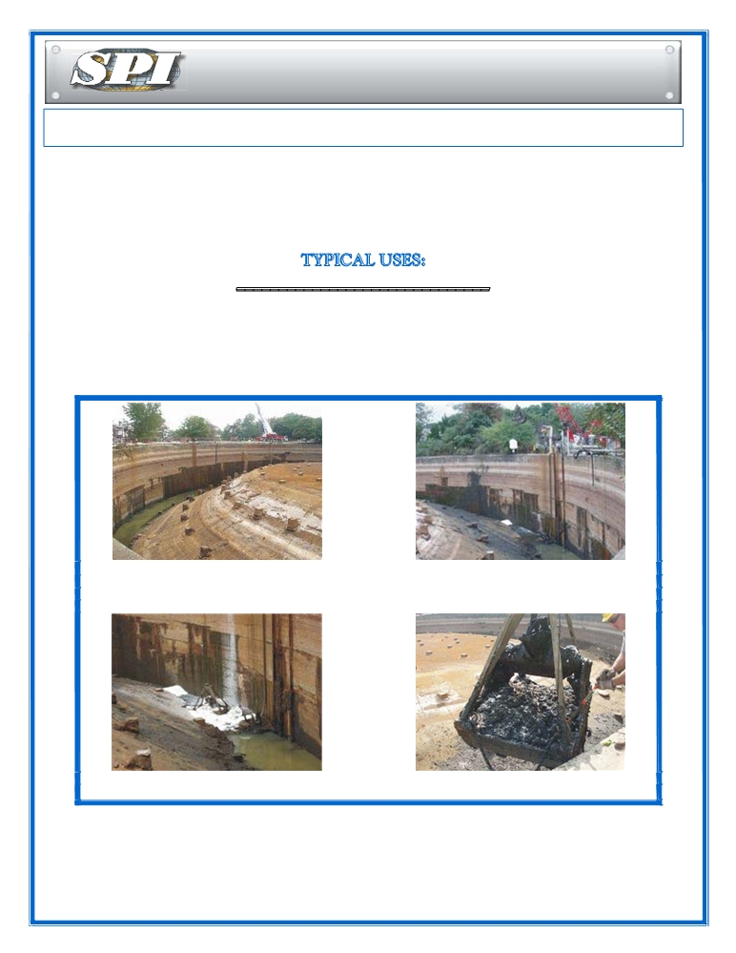

Solidification Products International

SPI WaterBond Fast Acting Aqueous Stabilizing Polymer
SPI WaterBond a white granular, water-absorbent polymer is designed to hold large volumes of aqueous
liquids quickly and reaches maximum absorbency in just 5-10 minutes. Because of the high absorbency only
a small amount of SPI WaterBond is required to treat large volumes of liquids. The amount of SPI
WaterBond applied, is based on the chemical nature and pH of the waste. Typical effective ranges are
from 25 to 500 times its dry weight, with absorbencies of 60 to 250 percent typical values for a wide variety of
waste streams.

PAINT SLUDGES INK SLUDES SEWER SLUDGES DRILLING MUDS
DRUMMED AQUEOUS WASTE DEICING FLUID SPILLS

SOLIDIFICATION OF LIQUIDS, SLUDGES AND MUDS

Manufactured Gas Plant Site with 8000 SPI Waterbond is used for Solidification
Cubic yards of Sludge Each Super sack is lowered into the pit
with a crane.

The crane clam shell is used to mix the When mixing is complete the Sludge has
Waterbond into the Sludge no Free liquid and is shipped for disposal

For sludges and muds which are predominantly aqueous based SPI WaterBond is often the ideal solution. Volume increase is minimal usually 1%, while solidifying all free liquid. SPI WaterBond transforms sludges and mud into a dry, firm semi-solid, with an increased load bearing strength; for material destined for landfill disposal.
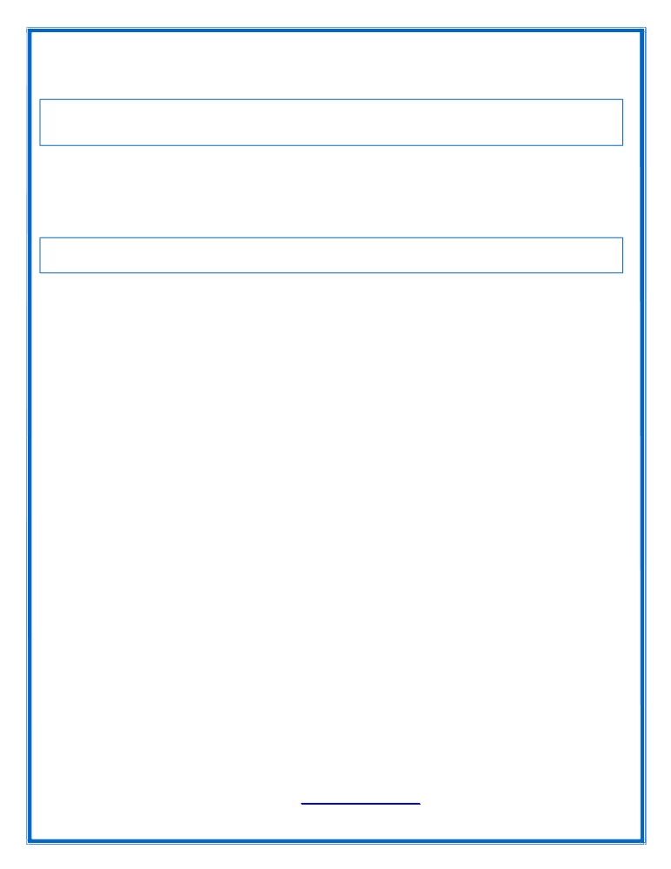

Reducing waste volume is now required by the EPA. Conventional absorbents such as clay, fly ash and
cement absorb a relatively small amount of liquid in relation to their dry weight. The volume of waste is
therefore doubled or tripled when compared with the amount of SPI WaterBond needed to complete
solidification.
TRANSPORTATION PROBLEM ELIMINATED

Often problems are encountered in transporting stabilized sludges and muds. During transportation loads shift and free liquids can migrate out of conventionally absorbed materials. With sludges and muds solidified with SPI WaterBond problems with leakage can be eliminated. Free liquid is absorbed and locked into a semi-solid form that will not release the absorbed material during transportation or under landfill pressures in excess of 50 PSI.
SPI WaterBond APPLICATION RATES
The proper mixing ratio is determined on a percentage by weight basis. Normal solidification requires from ¼% to 6% by weight of SPI WaterBond to the waste material. Solidification time will vary with viscosity and contents of the waste.

To test for ratios of the SPI WaterBond to waste, start with three 10 ounce cups. Add 100 grams of waste material to be solidified to each cup.

Cup #1 6% by weight or 6 grams of SPI WaterBond
Cup #2 3% by weight or 3 grams of SPI WaterBond
Cup #3 1% by weight or 1 grams of SPI WaterBond

After adding the SPI WaterBond , if the waste is a liquid just allow it to absorb and solidify without agitation.
All the free liquid should be absorbed within 10 minutes. When adding SPI WaterBond to a sludge or mud thoroughly mix it into the waste. Various mixed waste may require longer solidification times, in some cases up to 1 hour.

NOTE: These tests are a guide to determine the best ratio of SPI WaterBond . It may be determined that
2% by weight is the best mix ratio for proper solidification. Testing SPI WaterBond is essential to assure proper results and solidification hardness before job is started.
In the situation of sludge or mud in a pit, manhole, boat bilge etc., start at one end of the material to be
solidified. With a shovel or rake, blend the WaterBond directly into the sludge. For best results divide area into sections and do one at a time. Waste sludge will start to firm up and solidify in most cases within 15 minutes. After all sludge has been fully absorbed and solidified with no free liquid, the solid mass can be easily vacuumed or shoveled up for disposal.

SPI WaterBond used to solidify sludges or muds with high oil content should be used in conjunction with
SPI OilBond . The OilBond™ should be used first to lock up the floating oil, and then solidify the remaining

sludge with SPI WaterBond
.

Oil Barriers Australasia
P.O.Box 47, Matangi, New Zealand .
peter@oilbarriers.co.nz / 0064 274 85876 www.oilbarriers.co.nz

