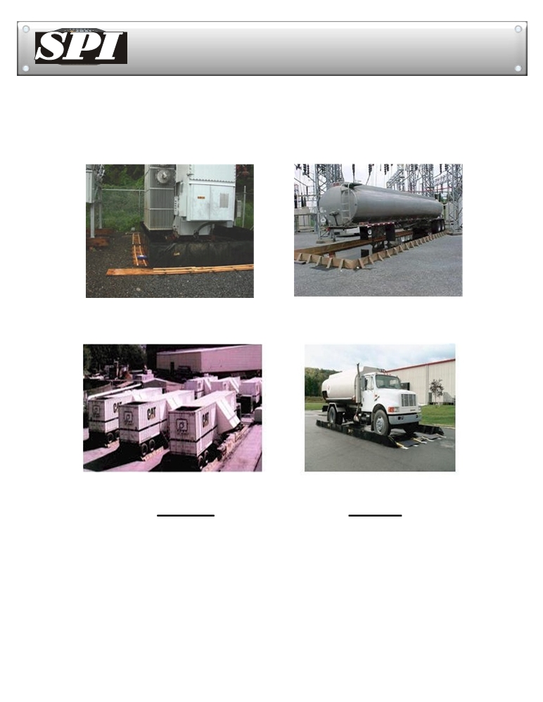

SPILL CONTAINMENT PORTABLE BERMS

Custom made 5.7 X 6.3 X 0.6m high wall with
Petro-Pipes. Uses angle iron to support berm
walls

Quick Berm inside strap used to contain Diesel Generators. 3 X 15 X 0.3m high wall
FEATURES

Quickberm easy to set-up, with outside
strap design offers a unique patented feature not offered any where else. Featured 3 X 15 X0.3m walls

Drive thru inside, quickly lower straps and drive on. 3 X 6 X 0.2m high wall
BENEFITS

· Heavy-duty aluminum strap support

· Exterior Straps
· Counterbalance technology
· Compact folded size
· One-piece design
· One year warranty on materials
And workmanship

· Straps and berm last longer with heavy usage
· Straps lay flat for drive-in
· No breakage from tires
· Easier to Clean and decon the sump area · Wind resistant walls
· Easier to Store
· No lost pieces, fast set up, ready to use · Buy with confidence
· US patent # 5,762,233

Oil Barriers Australasia
P.O.Box 47, Matangi, New Zealand .
peter@oilbarriers.co.nz / 0064 274 858763
www.oilbarriers.co.nz

