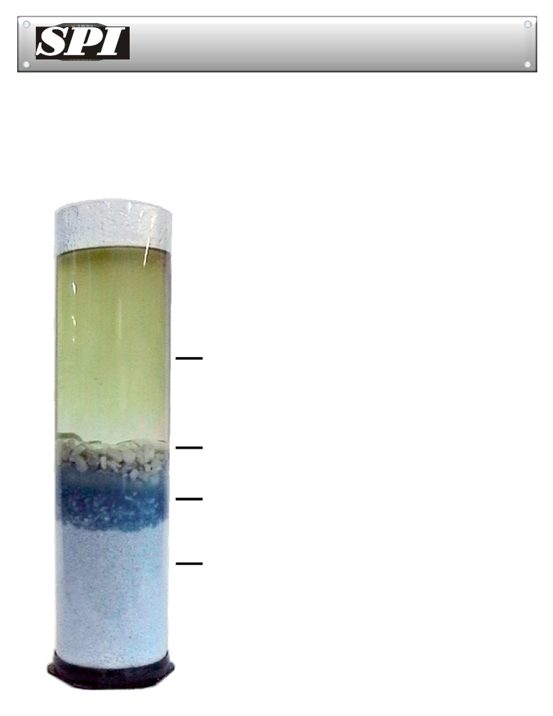
Solidification Products International, Inc.

TM
SPI Media Testing Data
How does it work?

SPI Barrier Media allows water to flow rapidly to discharge a containment area. If a large discharge of oil comes in contact with SPI Media it dissolves, forming an instant seal preventing any oil or water from further discharge. SPI Petro-Barriers™ are built with three different strengths of barrier media. This allows for water to pass through while removing oil sheen. In the event of a larger discharge of oil the SPI media completely seals..

☹ 






Rain Drains Oils Contained


™

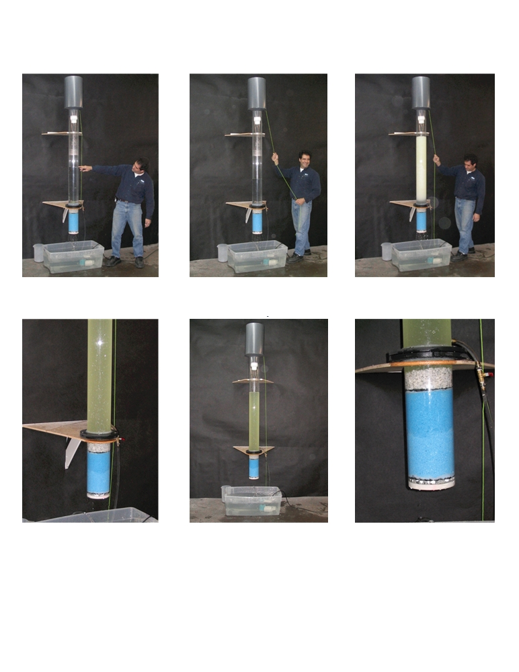
SPI Barrier Media Testing Data
Four Foot Head Pressure Test

Water has been flowing into the 150mm tube
and comes up to where Paul is pointing.

The oil and water take time to separate.

Just before the oil is dropped, we let the
water level fall to about 300mm.

Water flow has stopped. The Petro-Pipe™ held back 100% of the oil !

Five gallons of oil is released giving 100mm of
head pressure. The oil becomes emulsified with the water in the tube.

SPI’s media darkens as i t reacts with the oil.

Third Party Laboratory testing has also been done for the state of Florida DEP and has been approved as a method to be used for oil spill containment systems.
Oil Barriers Australasia
P.O.Box 47, Matangi, New Zealand .
peter@oilbarriers.co.nz / 0064 274 858763
www.oilbarriers.co.nz

